Module 2 – Architecture of Tableau
2.1 Architecture of Tableau
Tableau architecture explains how Tableau works with data sources, processes data, and displays dashboards and reports.
Main Components of Tableau
Data Source → Tableau Desktop → Tableau Server / Tableau Cloud → End Users
Components Explanation
Component | Description
Tableau Desktop | Used to create reports, charts, and dashboards
Tableau Server | Used to publish and share dashboards inside organization
Tableau Cloud | Online hosted Tableau platform
Data Sources | Excel, SQL, CSV, Oracle, MySQL, etc.
Tableau Prep | Used for data cleaning and preparation
End Users | Users who view dashboards

Tableau Architecture Diagram
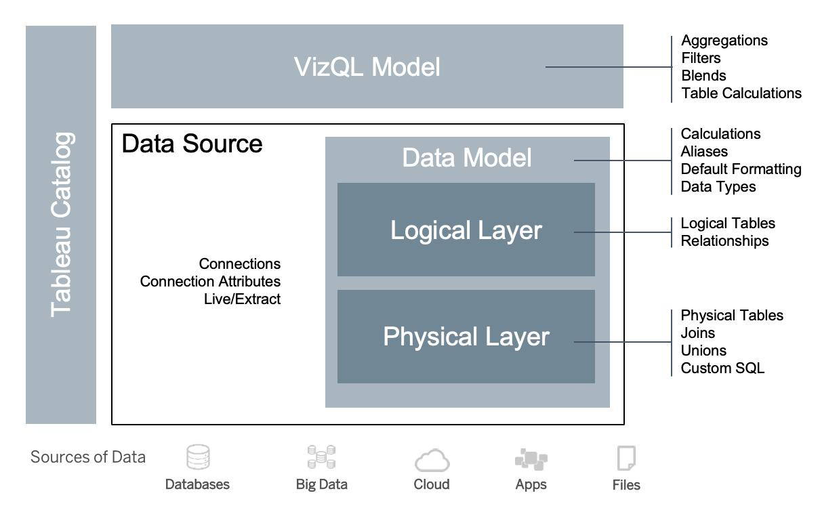
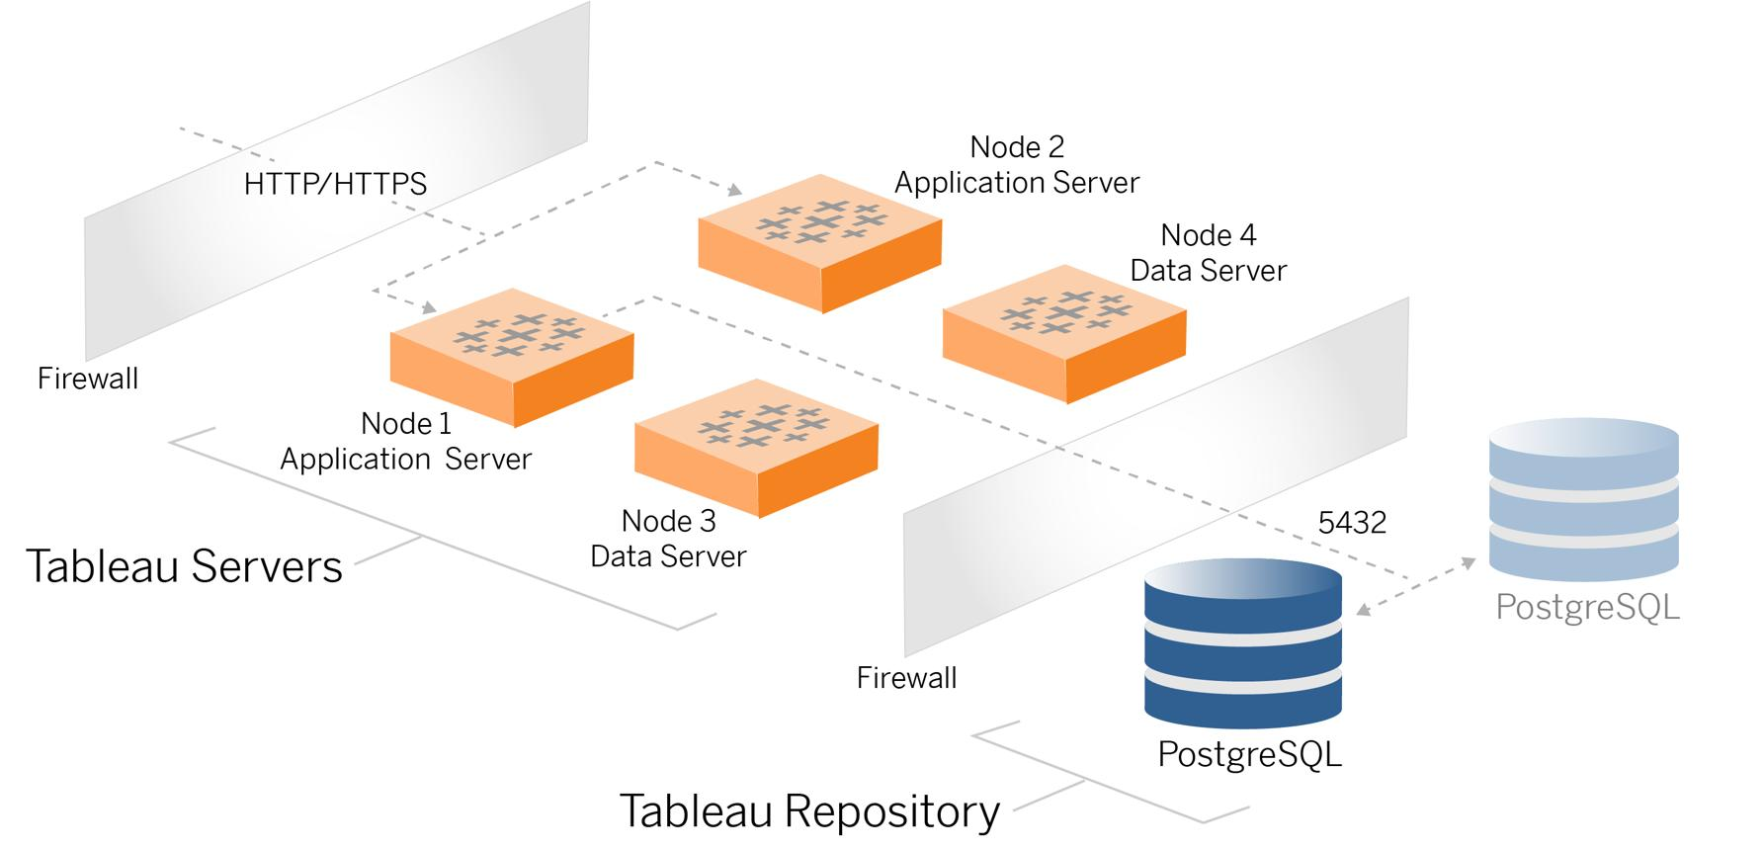
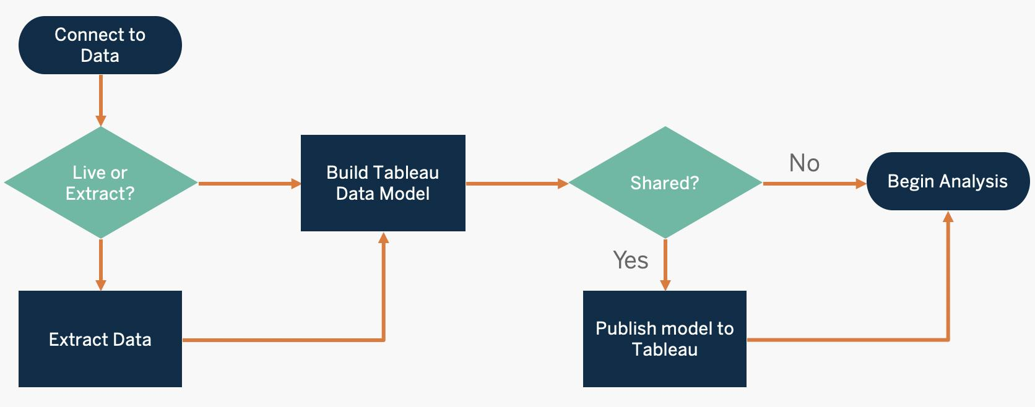

Workflow Example
Example:
A company stores sales data in Excel and MySQL.
- Connect Tableau to Excel/MySQL
- Create charts and dashboards
- Publish dashboard to Tableau Server
- Managers access reports using browser/mobile

2.2 Interface of Tableau
When Tableau opens, different sections are available.
Main Interface Components
Component | Purpose
Menu Bar | File, Data, Worksheet options
Toolbar | Quick action buttons
Data Pane | Tables, dimensions, measures
Analytics Pane | Trend lines, forecasts, clustering
Shelves | Rows, Columns, Filters, Pages
Marks Card | Color, Size, Label, Tooltip
Worksheet Area | Main visualization area
Dashboard Pane | Build dashboards

Tableau Interface Image
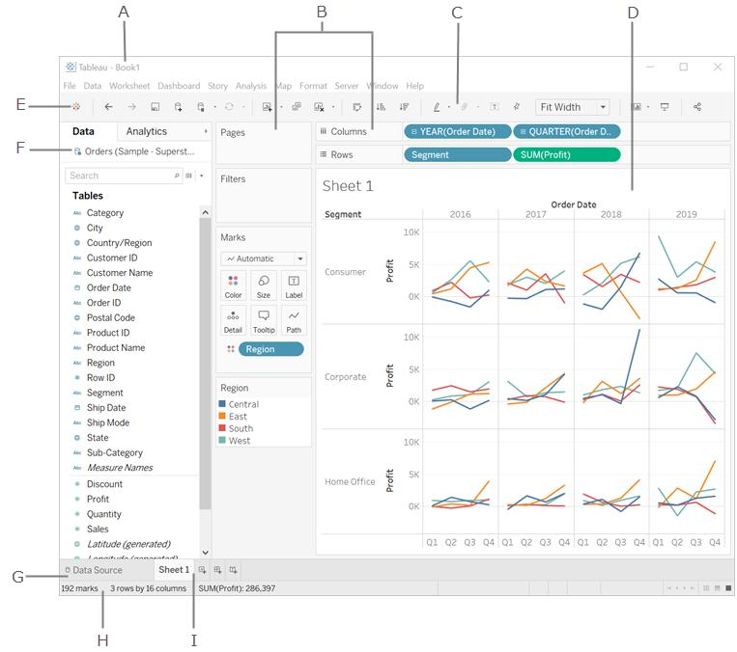
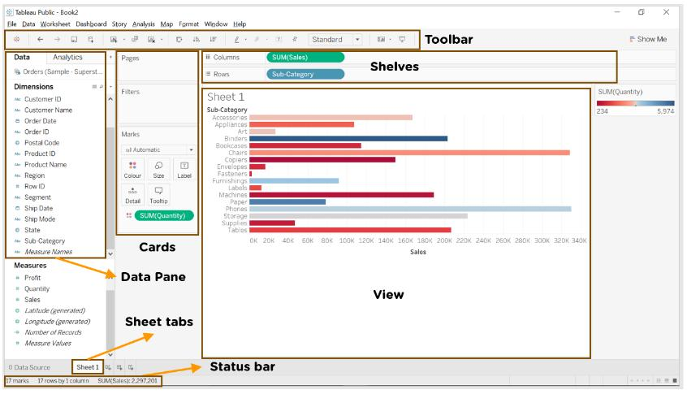
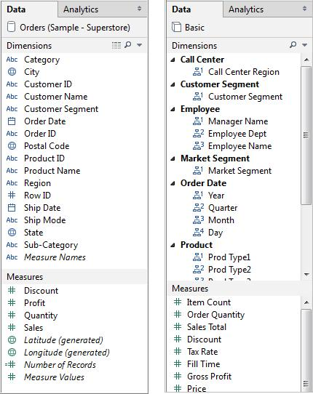

Important Areas
1. Data Pane
Contains:
- Dimensions
- Measures
- Tables
Example:
Field | Type
Name | Dimension
Salary | Measure
Age | Measure

2. Analytics Pane
Used for:
- Trend line
- Forecast
- Average line
- Cluster
Example:
Add trend line to sales chart.

3. Marks Card
Used to customize visualization:
- Color
- Size
- Label
- Tooltip
- Shape

2.3 Tableau Field Types
Tableau divides fields into two major categories.
1. Dimensions
Qualitative data.
Examples:
- Name
- City
- Department
- Product Category
Used for:
- Grouping
- Labeling
- Categorization

2. Measures
Quantitative numeric data.
Examples:
- Salary
- Sales
- Profit
- Quantity
Used for:
- Calculations
- Aggregations
- Analysis

Field Type Example
Employee Name | Department | Salary
Amit | IT | 50000

- Employee Name → Dimension
- Department → Dimension
- Salary → Measure

Tableau Dimension vs Measure
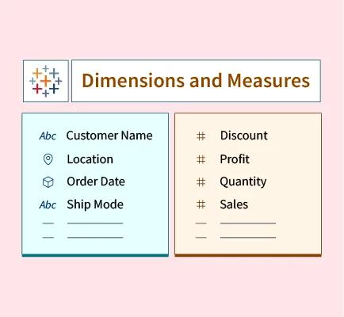

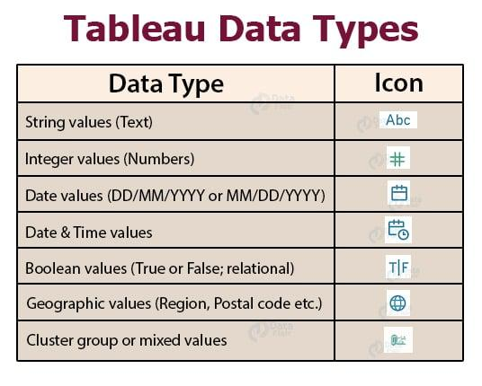
2.4 Saving and Publishing a Data Source
Saving Data Source
Steps:
- Connect data source
- Click Data
- Select Add to Saved Data Sources
- Give name
- Save
Benefit:
Reuse same data connection in multiple reports.

Publishing Data Source
Steps:
- Click Server
- Select Publish Data Source
- Choose project location
- Publish
Benefit:
Multiple users can access same data source.

Publishing Data Source Example
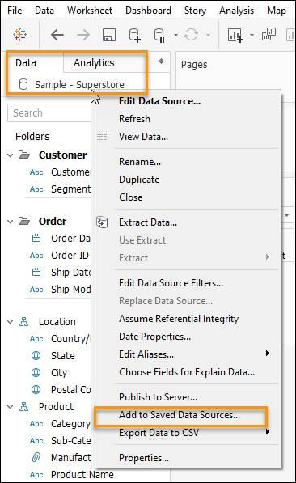
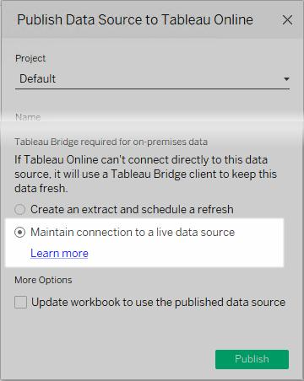
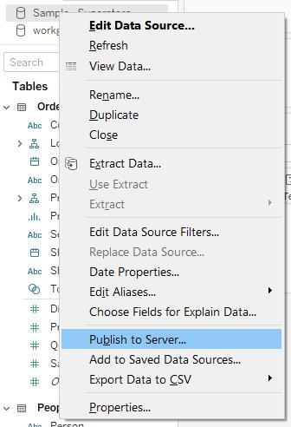

2.5 Live vs Extract Connection
1. Live Connection
Tableau directly connects to database.
Features:
- Real-time data
- Always updated
- Requires internet/database access
Example:
Sales dashboard connected directly to MySQL server.

2. Extract Connection
Tableau stores snapshot of data.
Features:
- Faster performance
- Works offline
- Data refresh needed manually/scheduled
Example:
Monthly HR report using extracted Excel data.

Live vs Extract Comparison
Feature | Live | Extract
Speed | Medium | Fast
Real-time | Yes | No
Offline Use | No | Yes
Database Load | High | Low

Live vs Extract Image
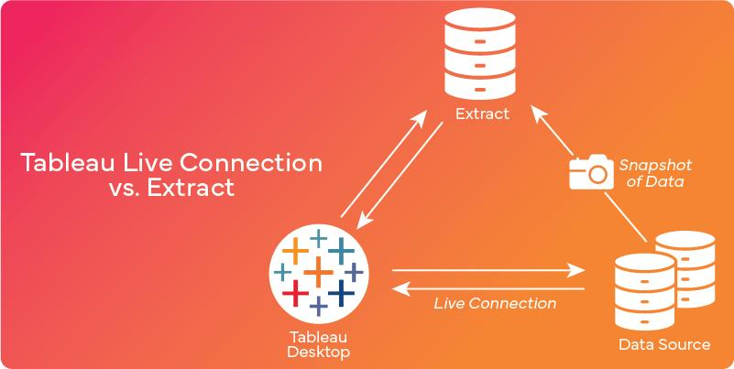
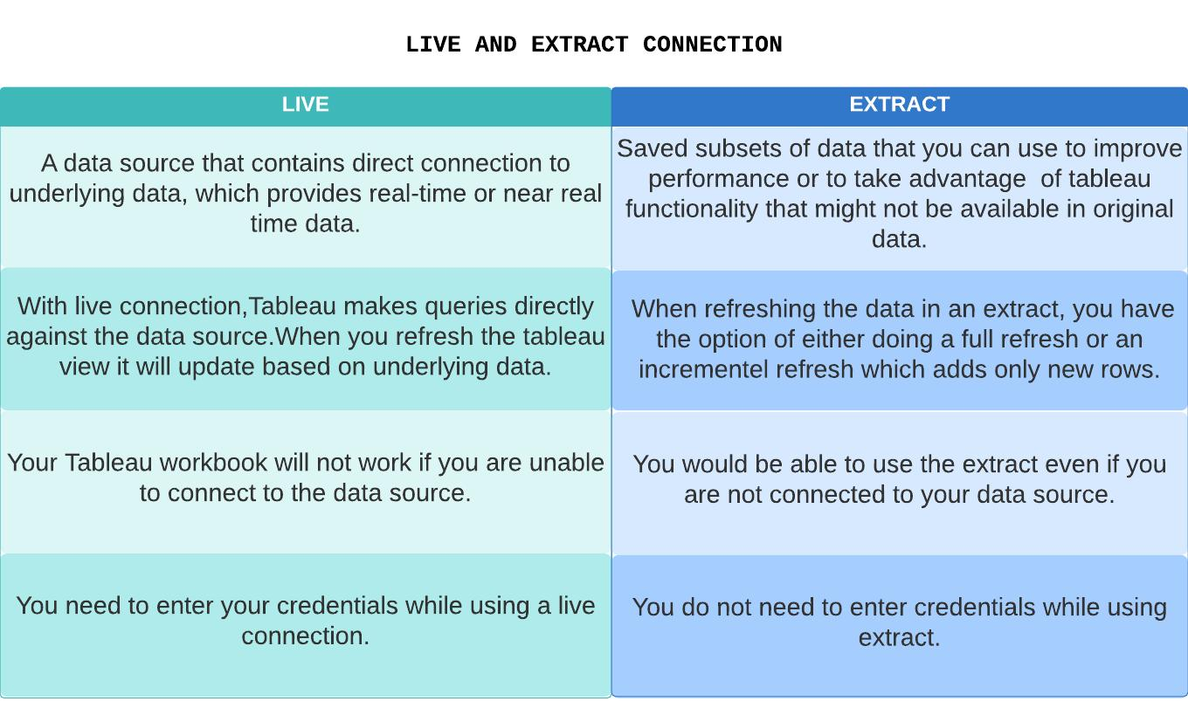
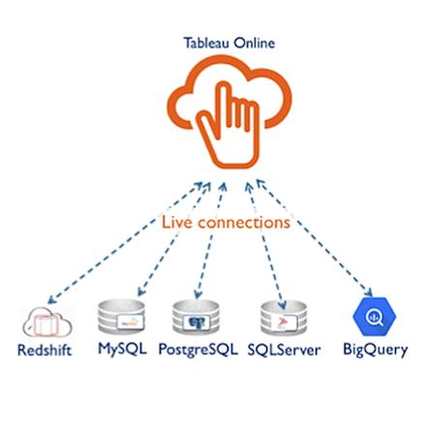
2.6 Various File Types in Tableau
File Type | Extension | Purpose
Tableau Workbook | .twb | Stores visualization only
Packaged Workbook | .twbx | Stores workbook + data
Data Extract | .hyper | Extracted data
Bookmark | .tbm | Single worksheet
Preferences | .tps | Custom preferences

Important Difference
.twb
- Small size
- No data included
.twbx
- Contains workbook + data
- Easy sharing

Tableau File Types Image
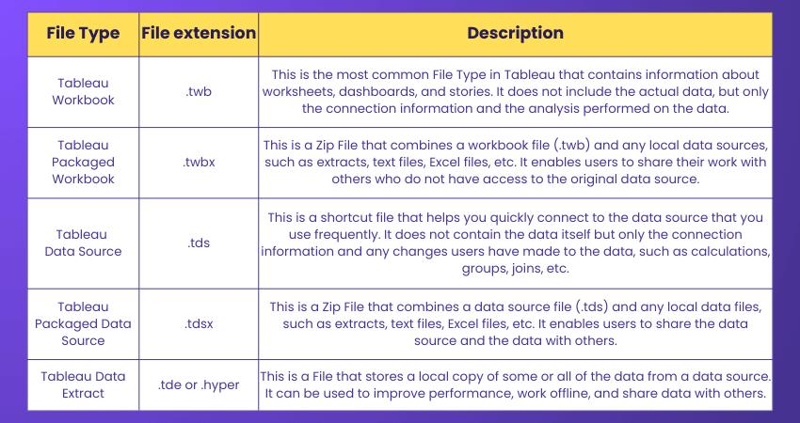
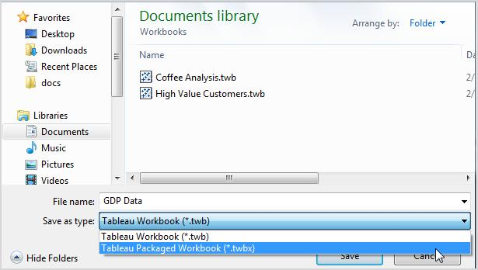
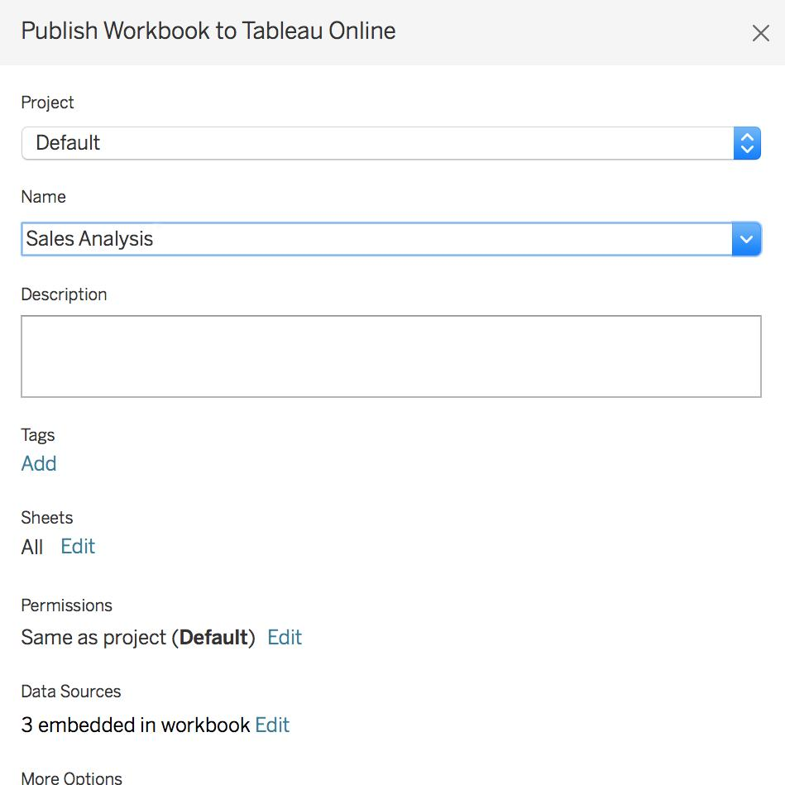

2.7 Ways to Share and Export Work in Tableau
Sharing Options
Method | Purpose
Tableau Server | Internal sharing
Tableau Cloud | Online sharing
PDF Export | Static report
Image Export | Screenshot
PowerPoint Export | Presentation
Packaged Workbook | Share complete workbook

Exporting Dashboard
Steps to Export PDF
- Open dashboard
- Click File
- Select Export as PDF
- Save location
- Export

Export as Image
Steps:
- Worksheet → Dashboard
- Click Worksheet
- Export → Image

Publish to Tableau Public
Steps:
- Create dashboard
- Click Server
- Select Tableau Public
- Login
- Publish

Tableau Sharing & Export Images
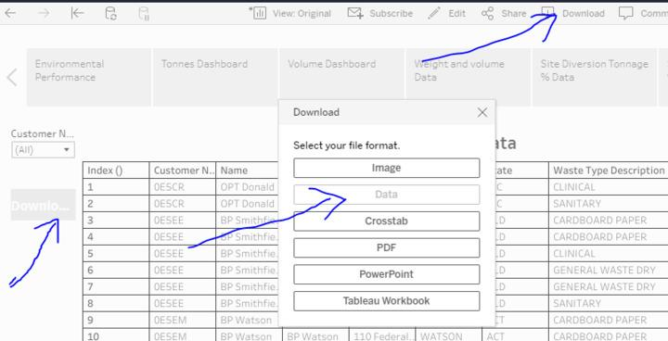

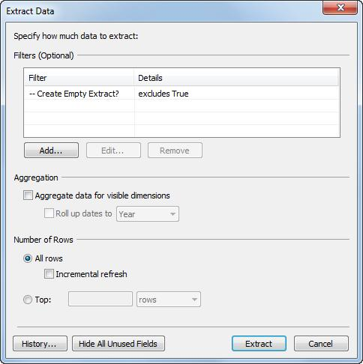

Hands-on Exercise
Exercise 1 – Play with Tableau Desktop
Task
Explore Tableau menus and options.
Steps:
- Open Tableau Desktop
- Click:
  - File
  - Data
  - Worksheet
  - Dashboard
- Observe available options

Exercise 2 – Learn Tableau Interface
Steps:
- Connect sample Excel file
- Observe:
  - Data Pane
  - Analytics Pane
  - Marks Card
  - Rows & Columns shelf
- Drag:
  - Name → Rows
  - Salary → Columns
Result:
Bar chart created automatically.

Exercise 3 – Share and Export Existing Work
Task 1: Export PDF
Steps:
- Open dashboard
- File → Export as PDF
- Save file

Task 2: Export Image
Steps:
- Worksheet → Export
- Choose Image
- Save PNG file

Task 3: Publish to Tableau Public
Steps:
- Server → Tableau Public
- Login
- Publish workbook

Real-Time Example
Sales Dashboard Example
Region | Sales
South | 45000
North | 67000
East | 52000
Visualizations:
- Bar chart for region sales
- Pie chart for category share
- Line chart for monthly trend
Export:
- PDF for management meeting
- Publish online for team access

Summary
In this module you learned:
- Tableau architecture
- Tableau interface
- Field types
- Live vs Extract
- Tableau file types
- Publishing and exporting dashboards
- Basic hands-on practice in Tableau

